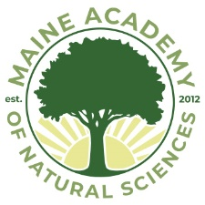

March 13, 2020

Dear Parent/Guardian:

I am writing to provide you with an update regarding the school’s ongoing preparation and response to the Corona Virus. We remain committed to the safety of our students and teachers as well as the larger communities and families of which they are a part of.

MeANS has no immediate plans for a school closure. We are in close, daily communication with the Maine Department of Education as well as the Maine CDC and will follow their recommendations. I encourage you to visit the following websites if you would like more direct information:

https://www.maine.gov/dhhs/mecdc/infectious-disease/epi/airborne/coronavirus.shtml
https://www.maine.gov/dhhs/press-release.shtml?id=2220078
https://www.maine.gov/doe/covid-19

With that said, our teachers are fully prepared to deliver two weeks of remote learning if necessary.

In addition to all the previous precautions we have done the following:
- Increased cleaning and disinfecting of all public areas including door handles, office equipment, vans, etc.
- Cancelled all work related, non-essential staff and teacher travel and participation in large off campus gatherings such as workshops and meetings
- Made adjustments to the food service and cafe

Please contact us with any questions or concerns. We appreciate your support and understanding during this difficult time and want the best for our students and families.

Sincerely,

Matthew L. Newberg
Head of School
Maine Academy of Natural Sciences
13 Easler Road
Hinckley, ME 04944
(207) 238-4102
www.meansacademy.org

