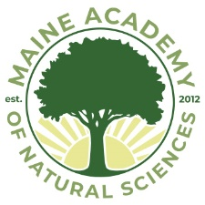

March 15, 2020

Dear Parent/Guardian:

I am writing to provide you with another update.

We have decided to close school and proceed with remote learning for the next two weeks. It was unclear as we headed into the weekend which way the State was going to move on this, but it is clear now.

Your student's advisor will be contacting them with specifics regarding remote learning expectations. MeANS is in a unique position having provided this service as part of our "snow day policy" for the last several years. Please feel confident that your children will be provided with educational continuity to the very best of our ability.

If you have any questions or concerns, Administration will be in the building on Monday, March 15th and will be sending out more information as necessary.

Sincerely,

Matthew L. Newberg
Head of School
Maine Academy of Natural Sciences
13 Easler Road
Hinckley, ME 04944
(207) 238-4102
www.meansacademy.org

